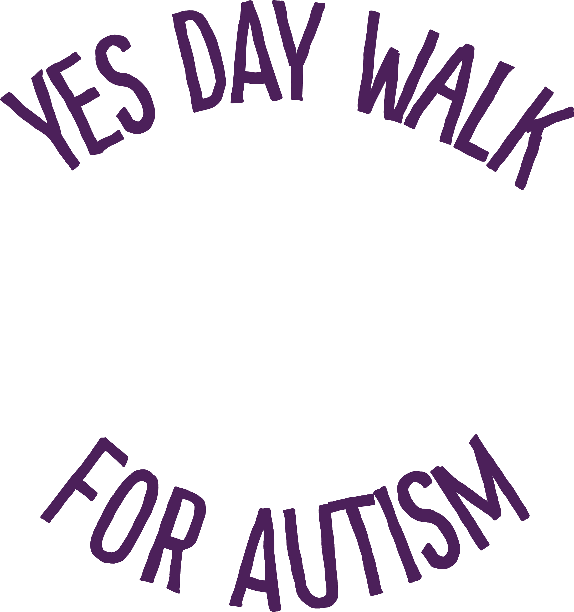

October 27, 2024

9 a.m. - 12 p.m.

Tempe Beach Park

**Say ‘YES’ & Donate to My Walk Team!**

YesDayforAutism.org

or scan my QR code

